Playwright Automation Training
Azure DevOps CI/CD Pipeline
Complete Practical Implementation Guide
Click-by-Click | Step-by-Step | With Screenshots Guidance
PHASE 1  Azure Account | PHASE 2  ADO Project & Repo | PHASE 3  Push Code | PHASE 4  Pipeline & Run

PHASE 1 | Create a Free Microsoft Azure Account

Before using Azure DevOps, you need a free Microsoft account. If you already have an Outlook, Hotmail, or Microsoft 365 account, you can use that directly.

Step 1.1 — Open Azure Sign-Up Page
🔗 URL: https://azure.microsoft.com/en-us/free

1 | Click the big green button 'Start free'  This is on the homepage — you cannot miss it. It may also say 'Try Azure for free'.

2 | You will be redirected to Microsoft's sign-in page  URL will change to login.microsoftonline.com
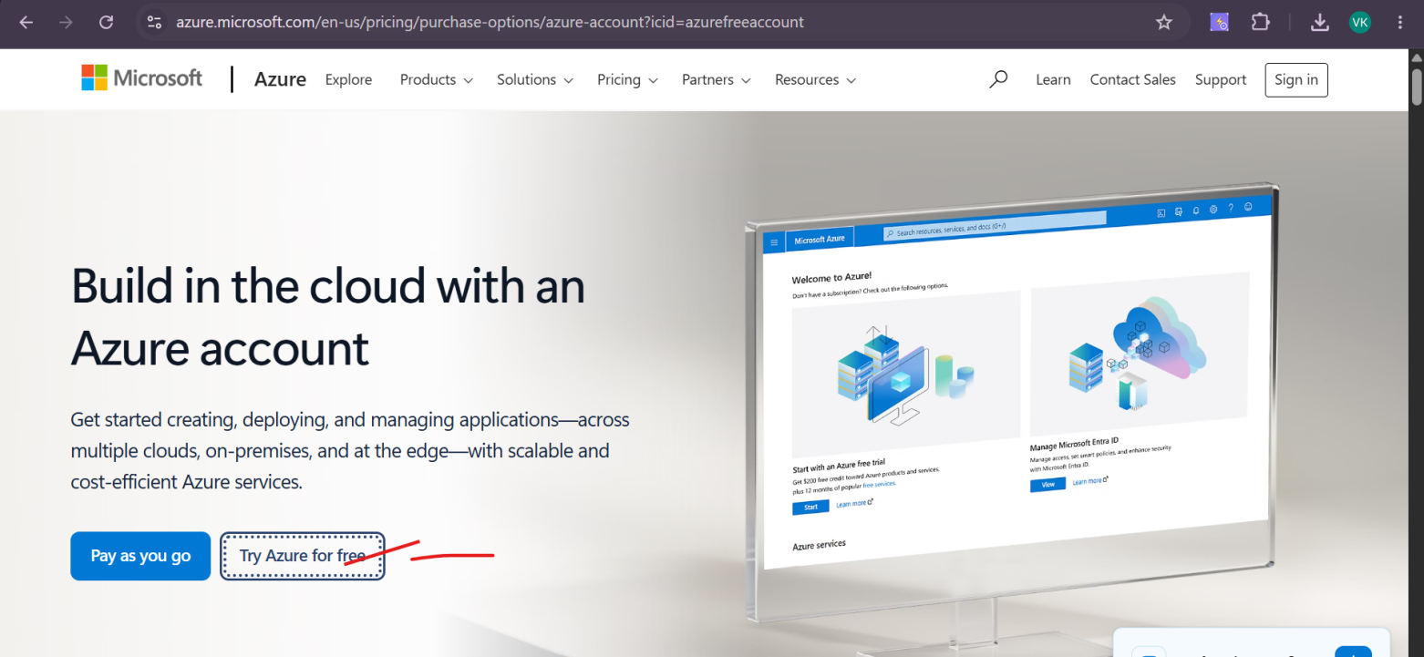

Step 1.2 — Sign In or Create Microsoft Account
💡 TIP: If you already have Gmail, you CANNOT use it directly. You need a Microsoft account. But you CAN create a Microsoft account using your existing Gmail address.

Option A — You already have a Microsoft/Outlook account
1 | Enter your existing email address (e.g. yourname@outlook.com)  Type in the email field and click Next

2 | Enter your password  Click Sign in

3 | If asked for MFA (phone verification), complete it  Microsoft may send an OTP to your phone

Option B — Create a new Microsoft account
1 | On the sign-in page, click 'Create one!'  It is a link below the email input field

2 | Enter an email address — use your existing Gmail or create a new Outlook address  If using Gmail: type yourname@gmail.com. If new: type a new username@outlook.com

3 | Click Next and set a strong password  Password must have uppercase, lowercase, number, symbol
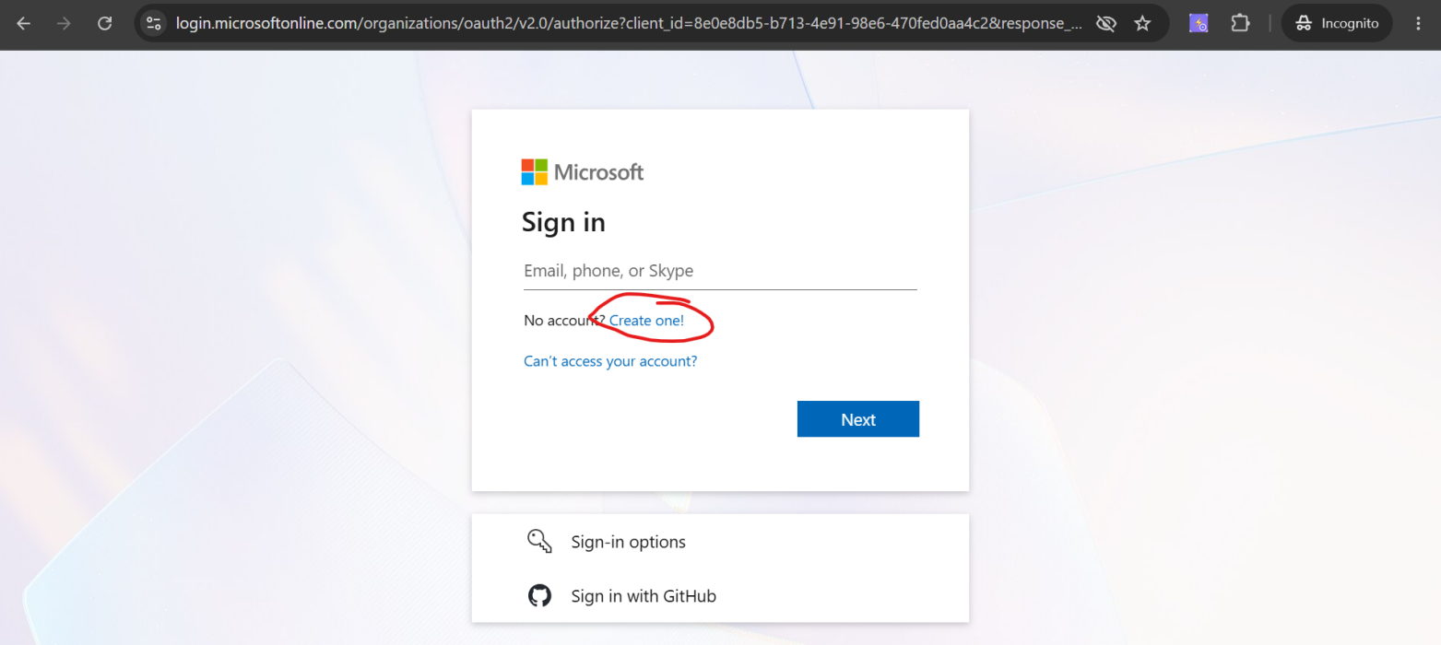
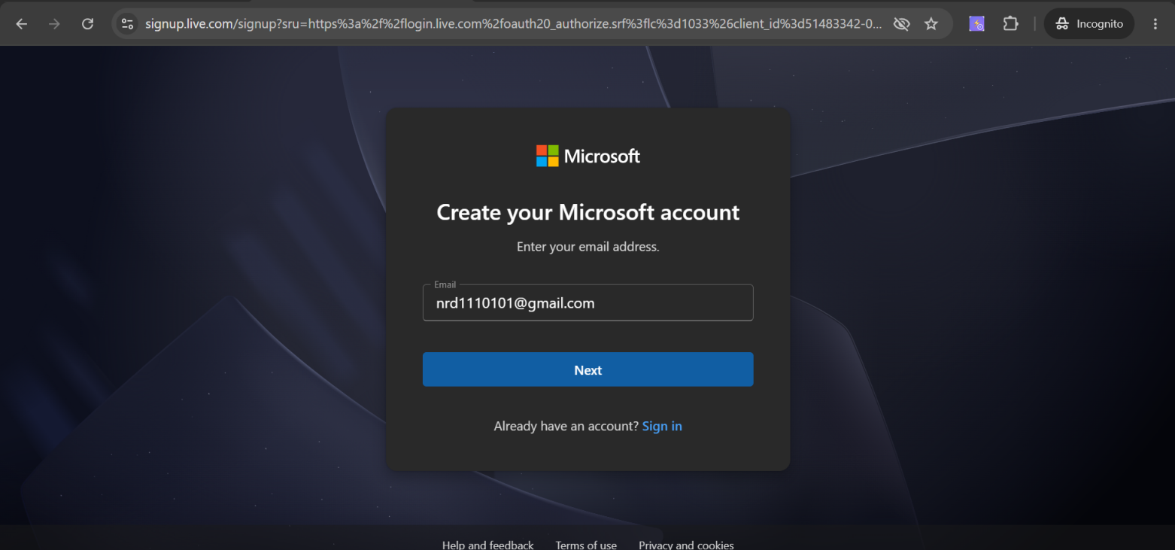

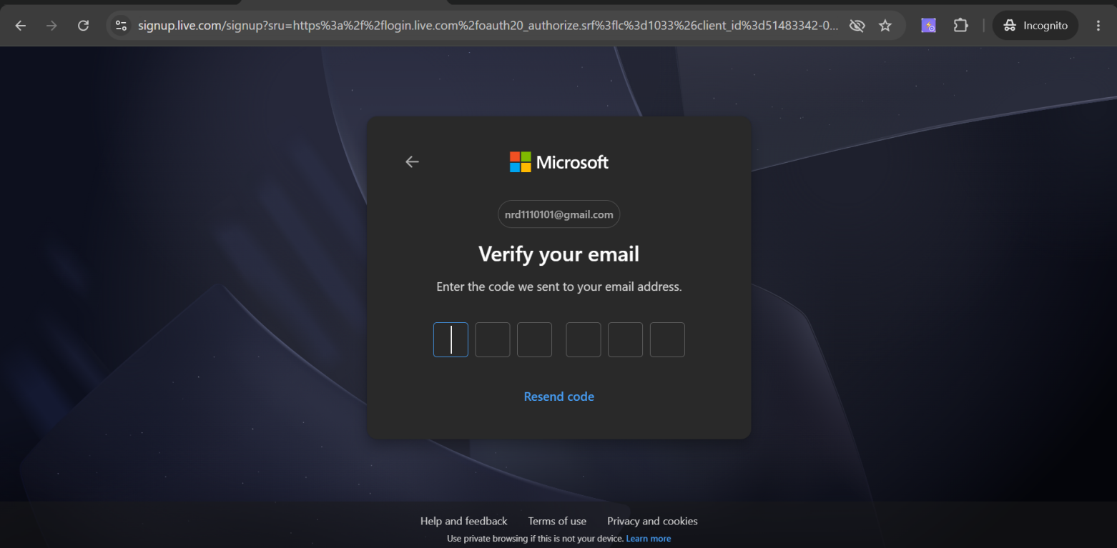

4 | Enter your first name and last name  Fill both fields, click Next

5 | Select your country and date of birth  Required for account creation

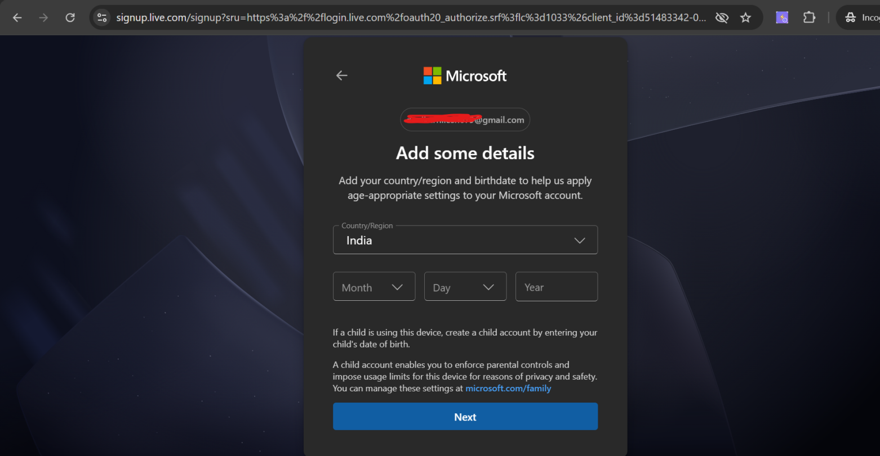
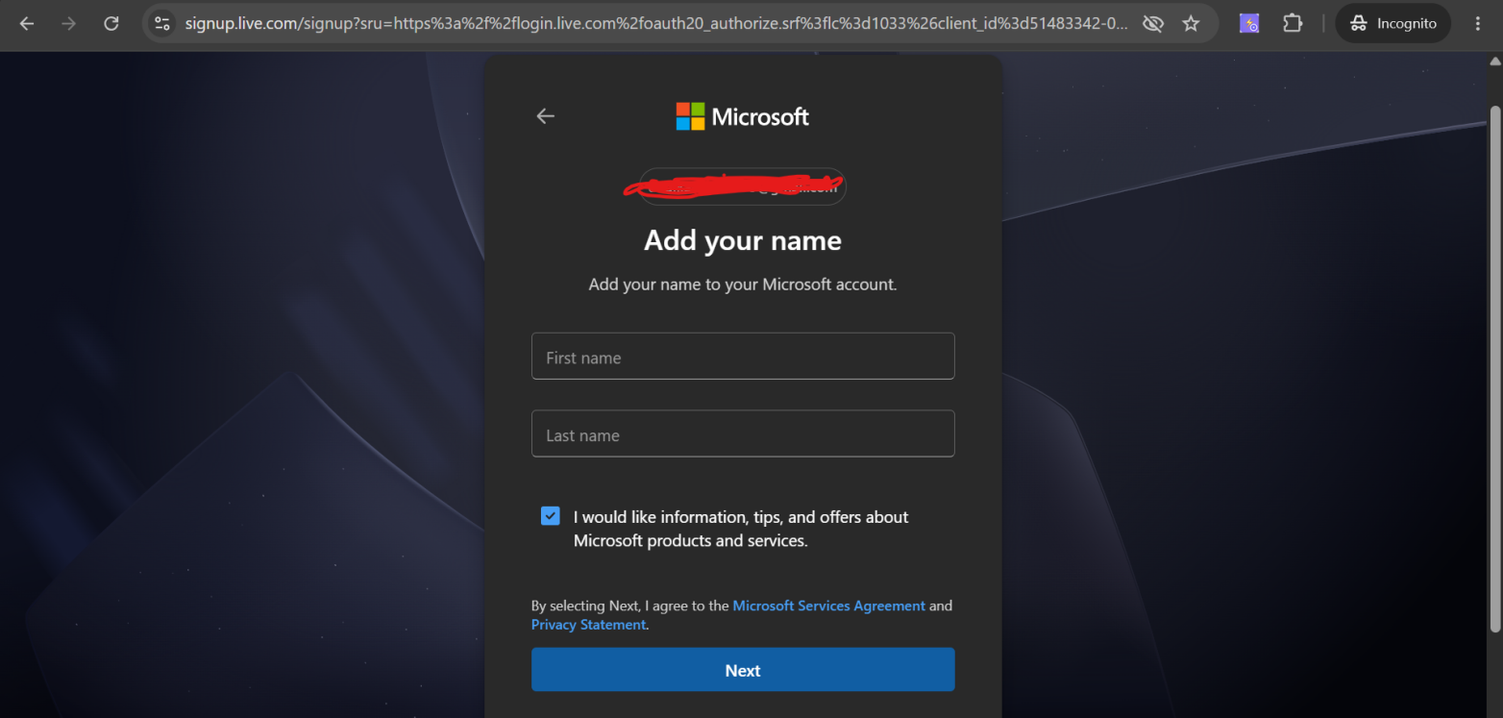

6 | Complete the CAPTCHA puzzle  Usually: solve a visual puzzle or click a checkbox

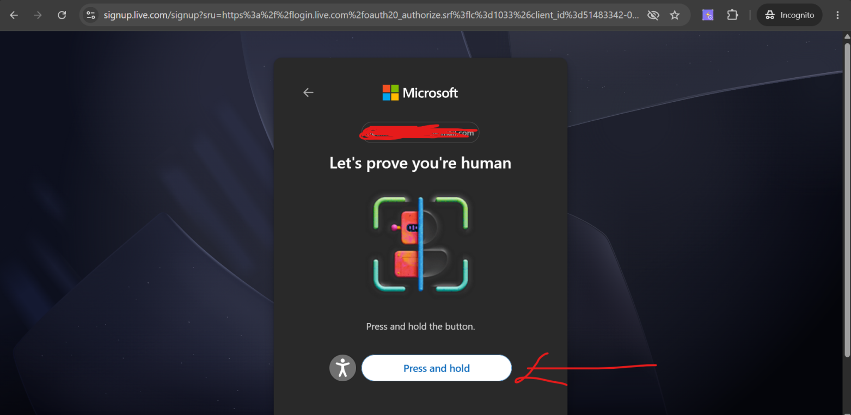

After press and hold-
Step 1.3 — Complete Azure Free Account Setup
🚨 IMPORTANT: Azure free account requires a credit/debit card for identity verification ONLY. You will NOT be charged unless you manually upgrade to pay-as-you-go. Students can use any debit card.

1 | After sign-in, you are on the Azure free account setup page  Fill in your profile information

Country/Region | India (or your country)

First Name | Your first name

Last Name | Your last name

Email address | Your email (auto-filled)

Phone | Your mobile number  Used for OTP verification

2 | Click Next  Move to phone verification step

3 | Enter your mobile number → Click 'Send code'  You will receive an SMS OTP
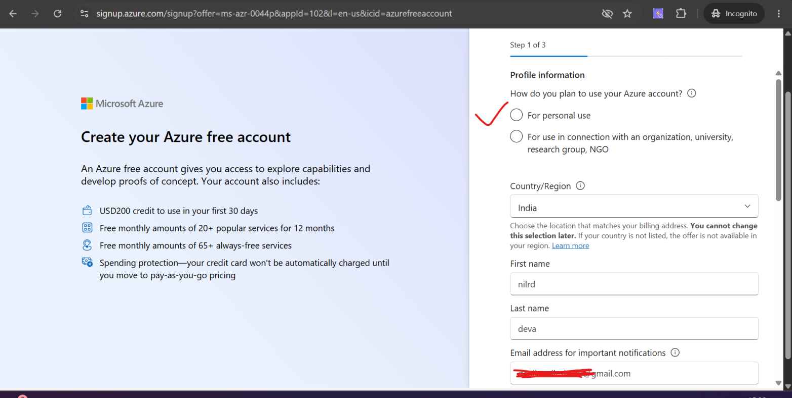

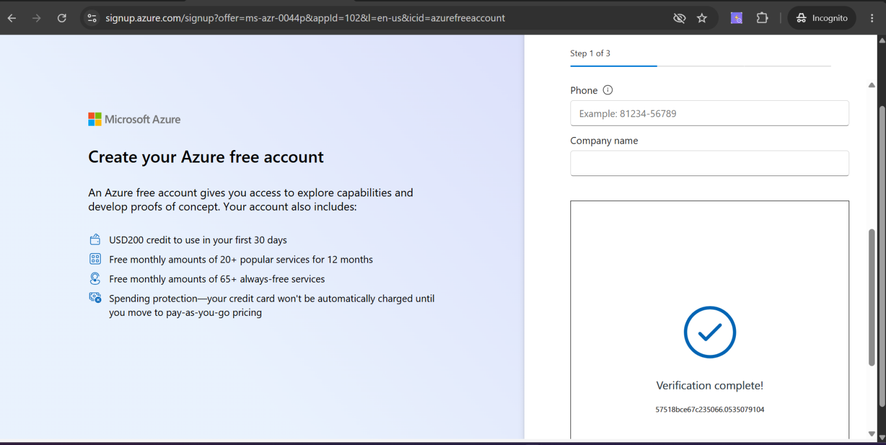

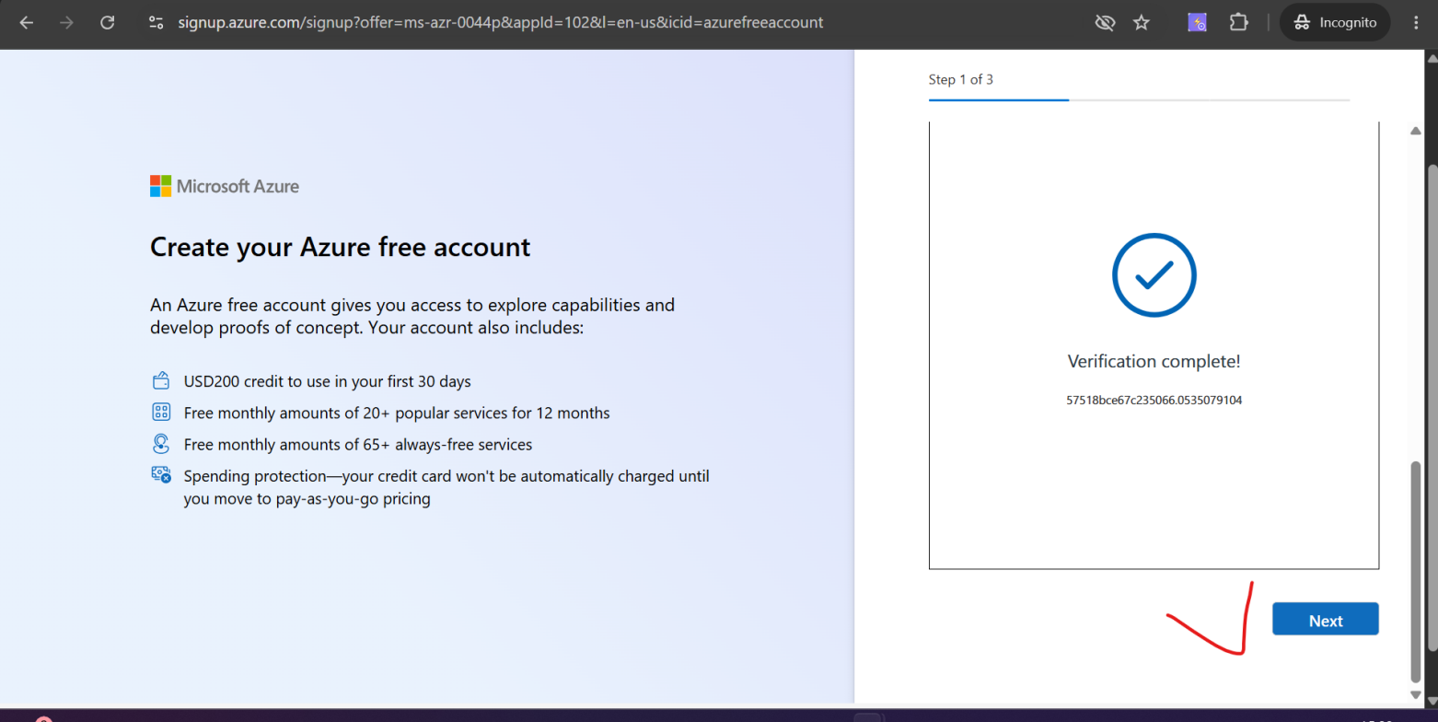
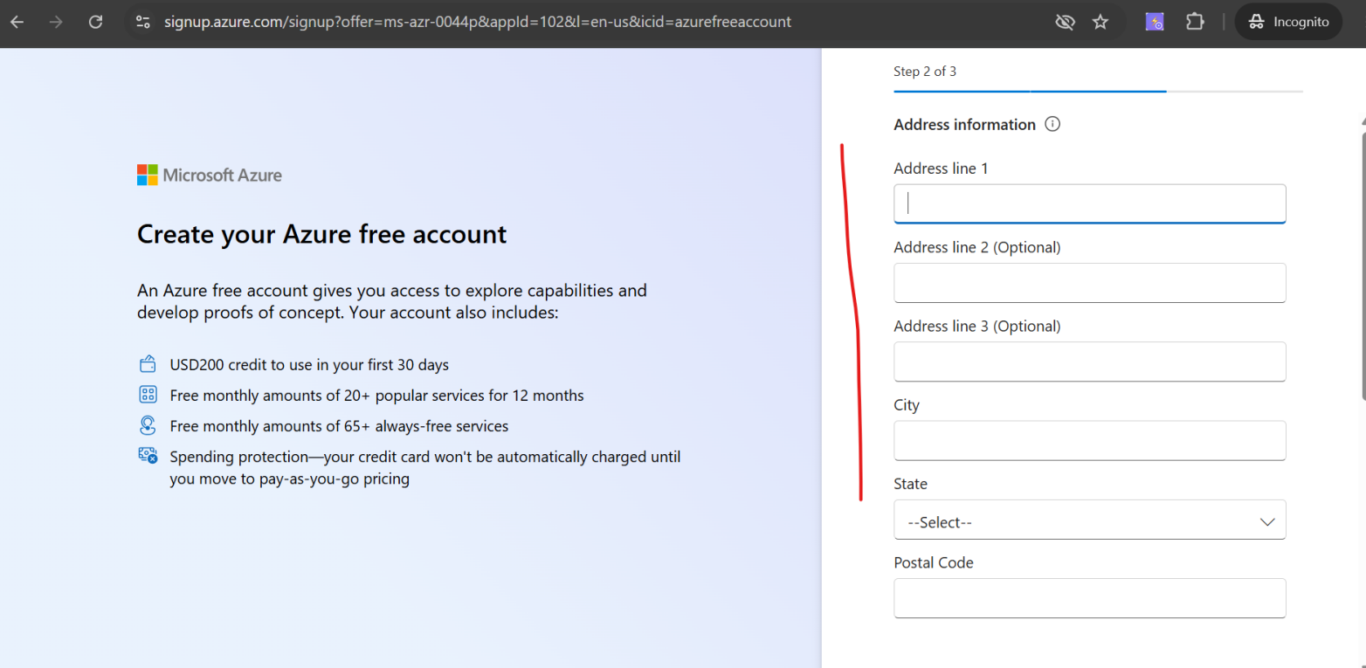

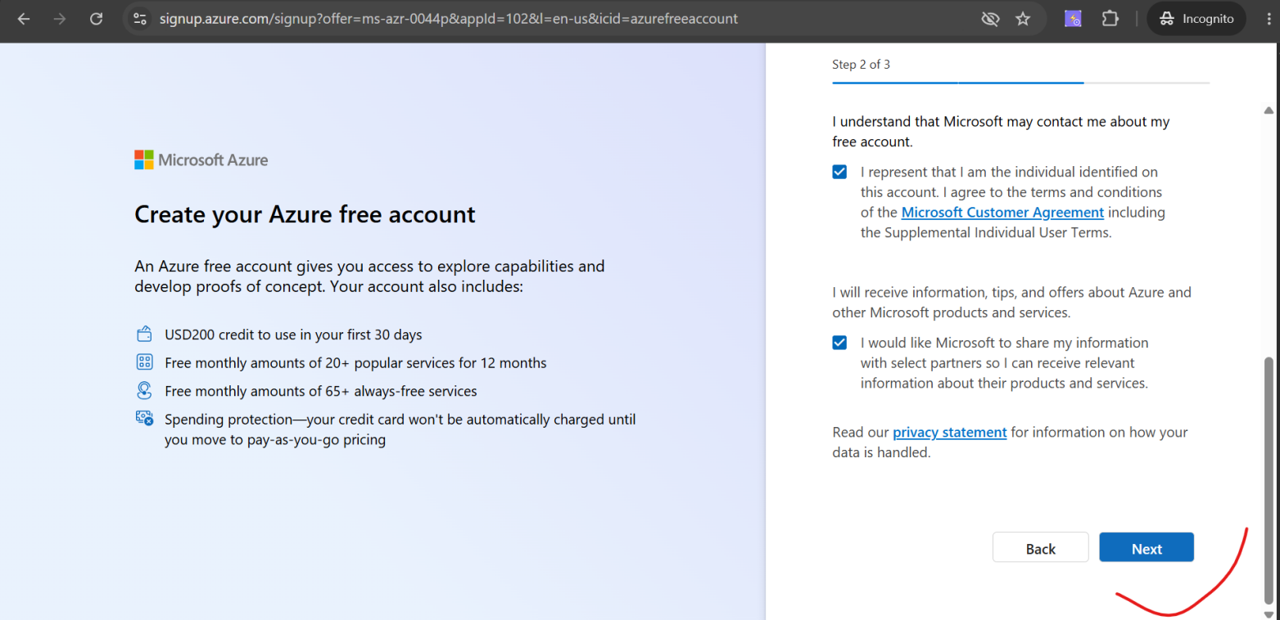

5 | On the Identity Verification page, enter your debit/credit card details  Card number, expiry, CVV. Azure charges ₹2 (refundable) for verification only.
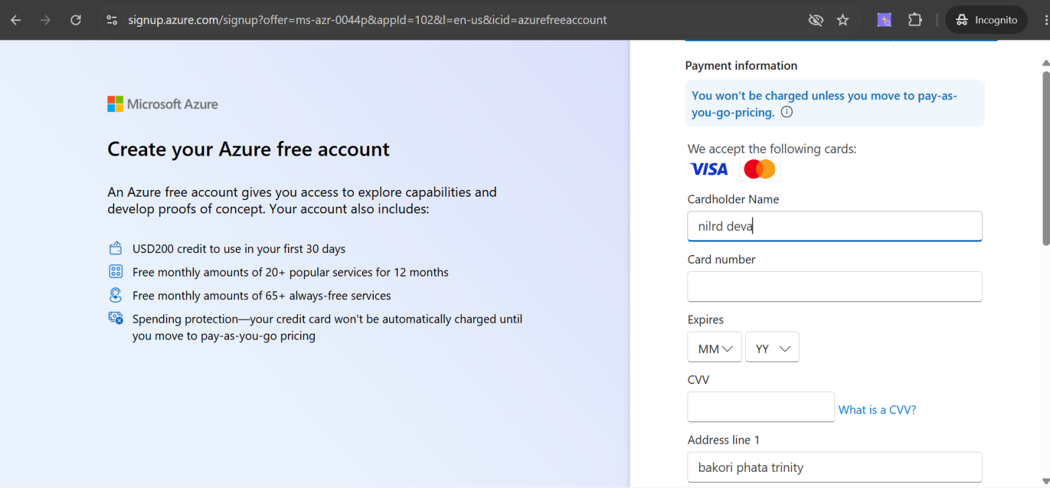

6 | Check the box 'I agree to the subscription agreement, offer details, and privacy statement'  Read it once — it confirms you get 12 months free and ₹13,300 free credits

7 | Click 'Sign up'  Azure will process for 30-60 seconds
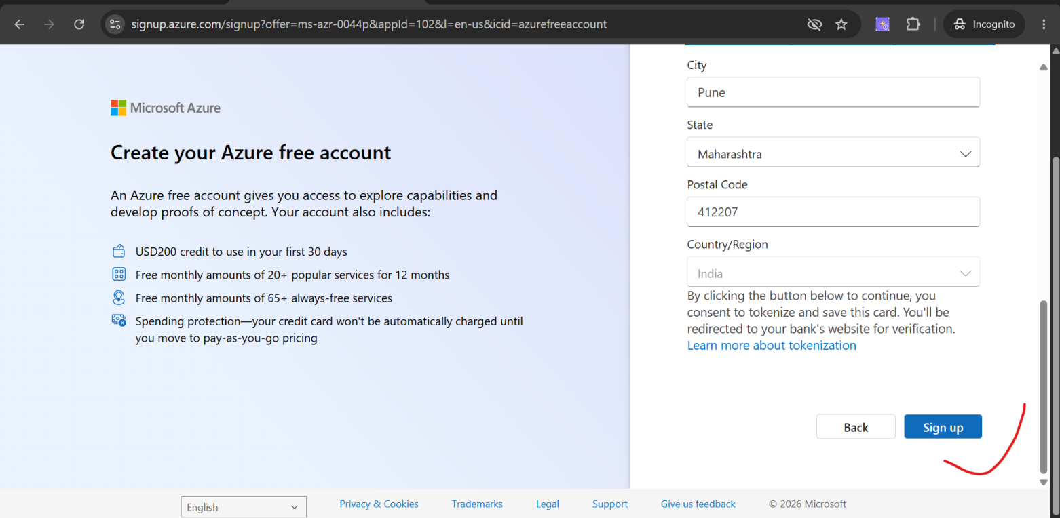
8 | You will see: 'You are ready to start with Azure'  Click 'Go to Azure portal'

💡 TIP: You are now on portal.azure.com — this is the Azure Portal. But we do NOT need Azure Portal for our purpose. We need Azure DevOps, which is a separate product at dev.azure.com.
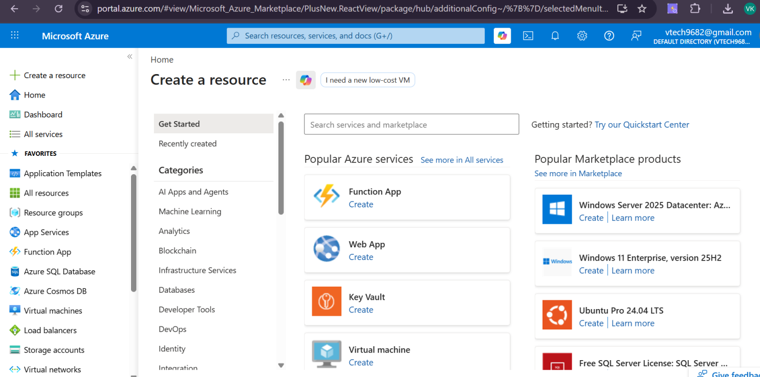

PHASE 2 | Set Up Azure DevOps Organization & Project

Azure DevOps is at a different URL from the Azure Portal. It is a completely separate product for software teams — Repos, Pipelines, Boards, Test Plans, Artifacts.

Step 2.1 — Open Azure DevOps
🔗 URL: https://dev.azure.com

1 | Go to https://dev.azure.com in your browser  Use the same Microsoft account you just created

2 | Sign in with your Microsoft account if prompted  Enter email → Next → Password → Sign in

3 | If asked 'Get started with Azure DevOps' — click Continue  It may ask for your name confirmation — click Continue
If not asked then use below link
https://aexprodcin1.vsaex.visualstudio.com/signup/?mkt=en-US&acquisitionType=byDefault
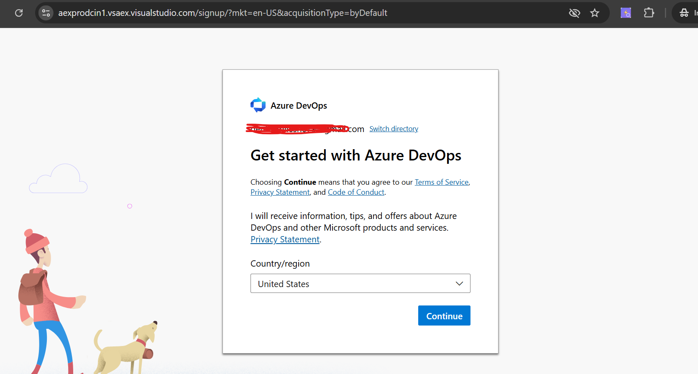
Below2.2 step is skipped for free acount--

Step 2.2 — Create Your Azure DevOps Organization
📌 INFO: An Organization in Azure DevOps is like your company's container. All projects live inside an organization. You get a free organization with 1 Microsoft-hosted parallel job (enough for training).

1 | You will see: 'Create new organization'  Click it

2 | On the 'Almost there' screen, accept the Terms of Service  Click Continue

Organization name | PlaywrightTraining (or your preferred name)  Only letters, numbers, hyphens allowed. No spaces.

Host your projects near | India (South Asia) — select from dropdown  Choose the region closest to you for speed

3 | Complete the CAPTCHA if shown  Click the checkbox or solve the puzzle

4 | Click 'Continue'  Azure DevOps creates your organization in seconds

Step 2.3 — Create Your First Project
After organization is created, Azure DevOps automatically shows you a 'Create a project' screen.
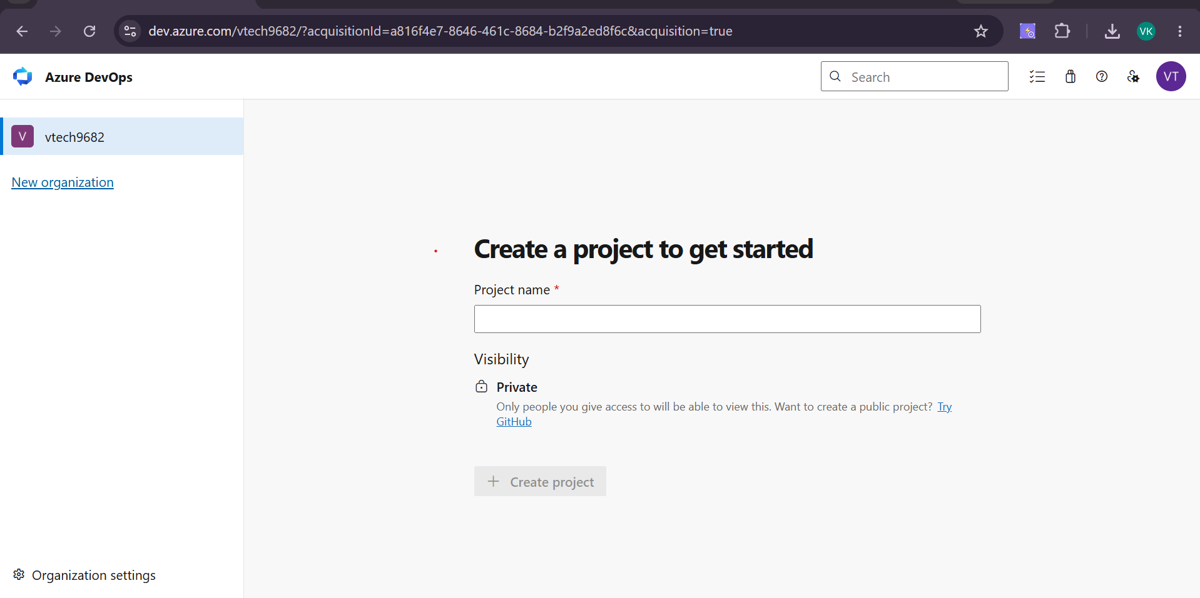

Project name | PlaywrightAutomation  Use this exact name — no spaces

Description | Playwright TypeScript CI/CD Demo Project  Optional but helpful

Visibility | Private  Do NOT select Public for training projects

Step Skipped for free account-
1 | Click 'Advanced' to expand more options

Version control | Git  Make sure Git is selected, NOT TFVC

Work item process | Scrum  Scrum or Basic — either works

2 | Click 'Create project'  Azure DevOps sets up the project — takes 5-10 seconds

3 | You are now inside your project dashboard  You will see: Boards, Repos, Pipelines, Test Plans, Artifacts in the left sidebar

💡 TIP: Show students all 5 sections in the sidebar briefly. For today: we only use REPOS and PIPELINES. The others are for future sessions.

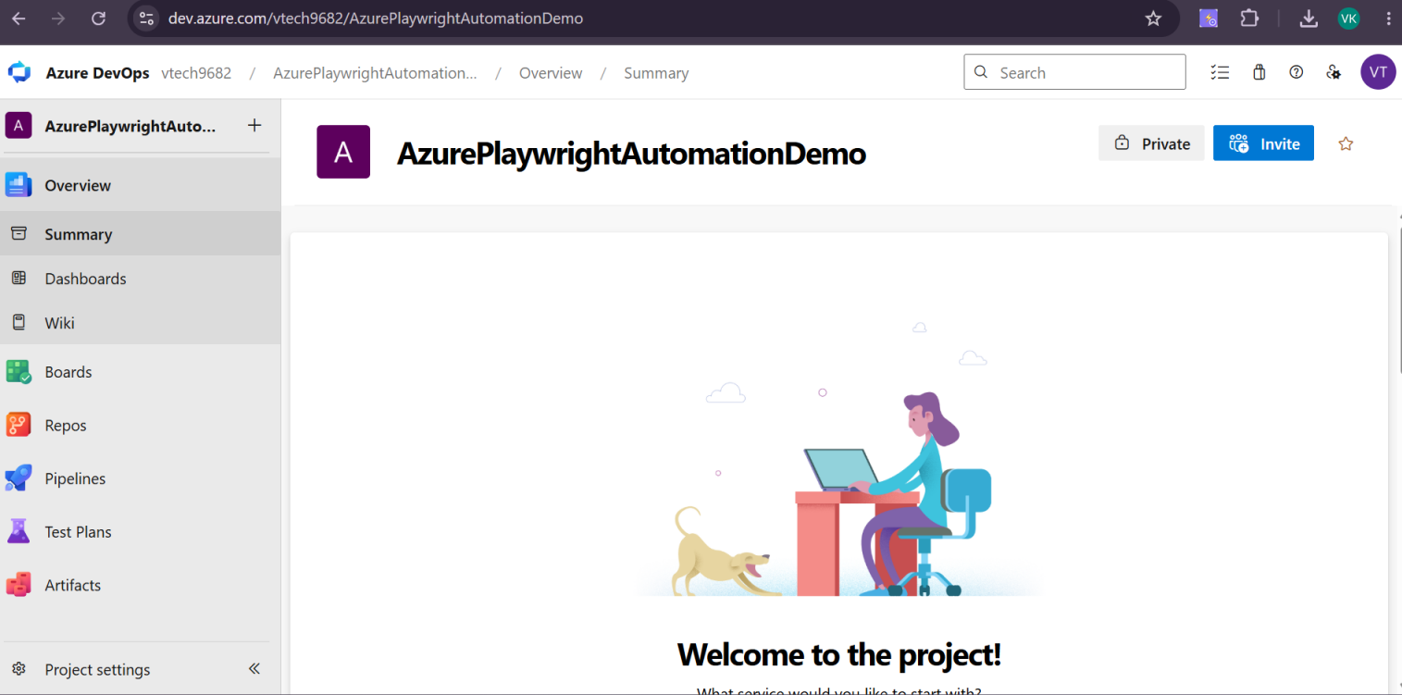
PHASE 3A | Create Personal Access Token (PAT) for Git Authentication

When you push code from your local machine to Azure Repos using Git, it will ask for a password. You CANNOT use your Microsoft account password here. You must use a Personal Access Token (PAT).

🚨 IMPORTANT: Do NOT skip this step. Without a PAT, the git push command will fail with authentication error.

Step 3A.1 — Generate a PAT
1 | In Azure DevOps, look at the top-right corner of the screen  You will see your profile picture/initials

2 | Click on the user icon (top-right)  A dropdown menu appears

3 | Click 'Personal access tokens'  This opens the PAT management page

4 | Click '+ New Token' button  The 'Create a new personal access token' panel slides in from the right

Name | PlaywrightCI_Token  Give it a meaningful name

Organization | PlaywrightTraining  Should be pre-selected

Expiration | 90 days  Select from dropdown — or Custom for a specific date

Scopes | Custom defined  Select this option instead of Full access

Under Scopes, check ONLY these boxes:
- Code → Read & write (MANDATORY — for git push/pull)
- Build → Read & execute (MANDATORY — to trigger pipelines)
- Test Management → Read & write (Optional — only if using Test Plans)

5 | Click 'Create'  Azure DevOps generates your token

🚨 IMPORTANT: A pop-up shows your PAT token — a long string like: abc123xyz456... COPY IT NOW. Once you close this dialog, you CANNOT see it again. Save it in Notepad immediately.

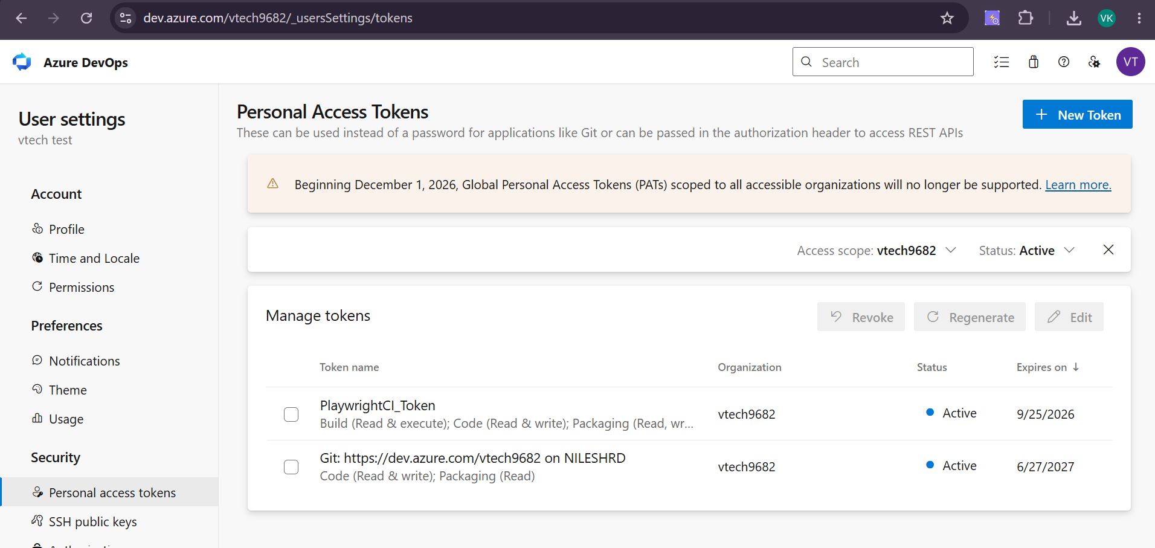
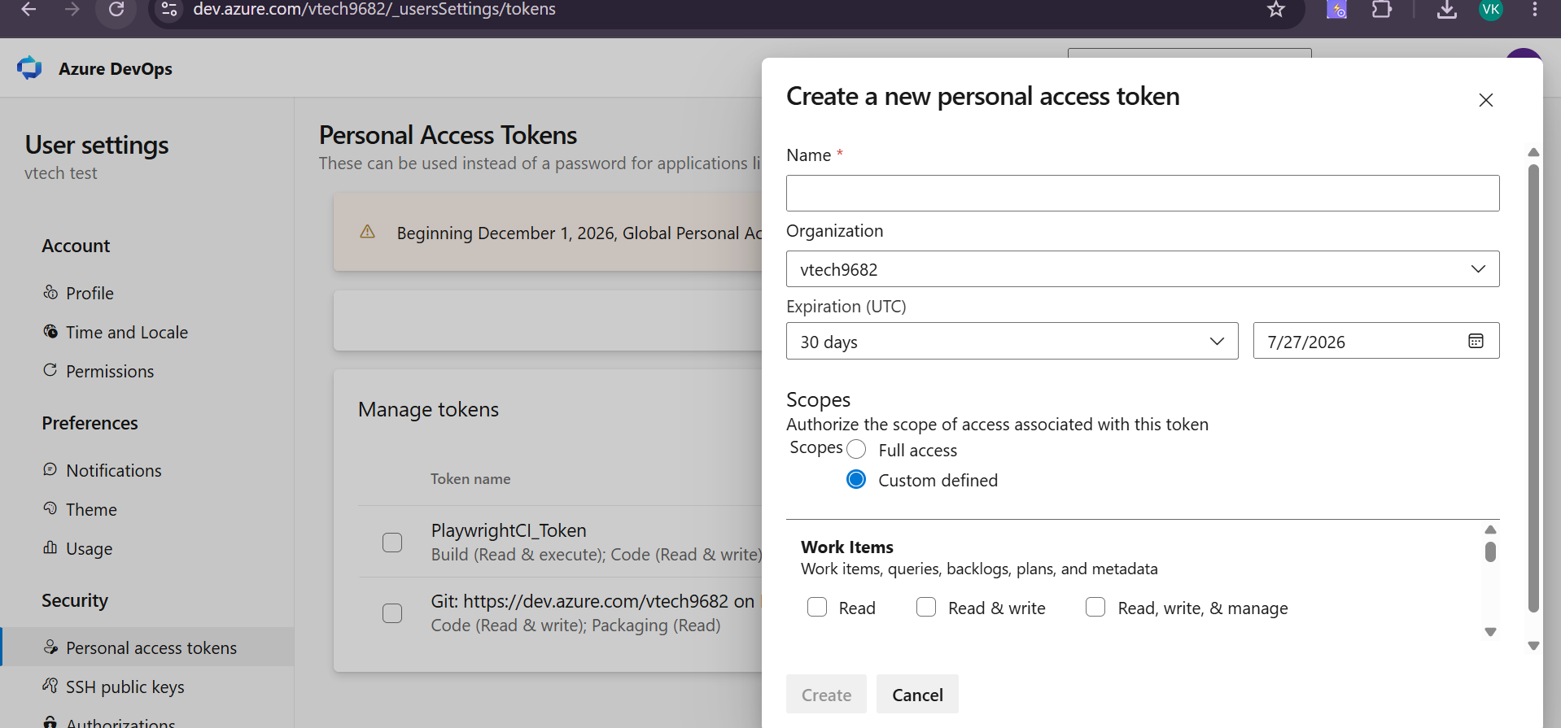

6 | Click the copy icon next to the token  Paste it in Notepad or keep it ready -token below  5Y5BXBFty4ZmbX66rISR51Uvg1uhQQaZ34tNfCPVXyf6kcxzxoIcJQQJ99CFACAAAAAAAAAAAAASAZDO2rzX  NewToken- lpXwad9ULjloLtRO9zN7fNN0gNuLHfpSEJ9cEEeeaBJYycSD7p9IJQQJ99CGACAAAAAAAAAAAAASAZDO2wYJ

7 | Click 'Close'

PHASE 3B | Push Your Playwright Project to Azure Repos

Now we connect your existing Playwright project (from previous training sessions) to Azure Repos and push the code.

Step 3B.1 — Get Your Repository URL from Azure DevOps
1 | In your Azure DevOps project, click 'Repos' in the left sidebar

2 | Click 'Files'  You will see an empty repository with setup instructions

3 | Look for the section 'Push an existing repository from command line'  This has the exact commands you need

4 | Click the copy icon next to the remote URL  It looks like: https://PlaywrightTraining@dev.azure.com/PlaywrightTraining/PlaywrightAutomation/_git/PlaywrightAutomation

💡 TIP: Save this URL — you will use it in the next step as your git remote origin.
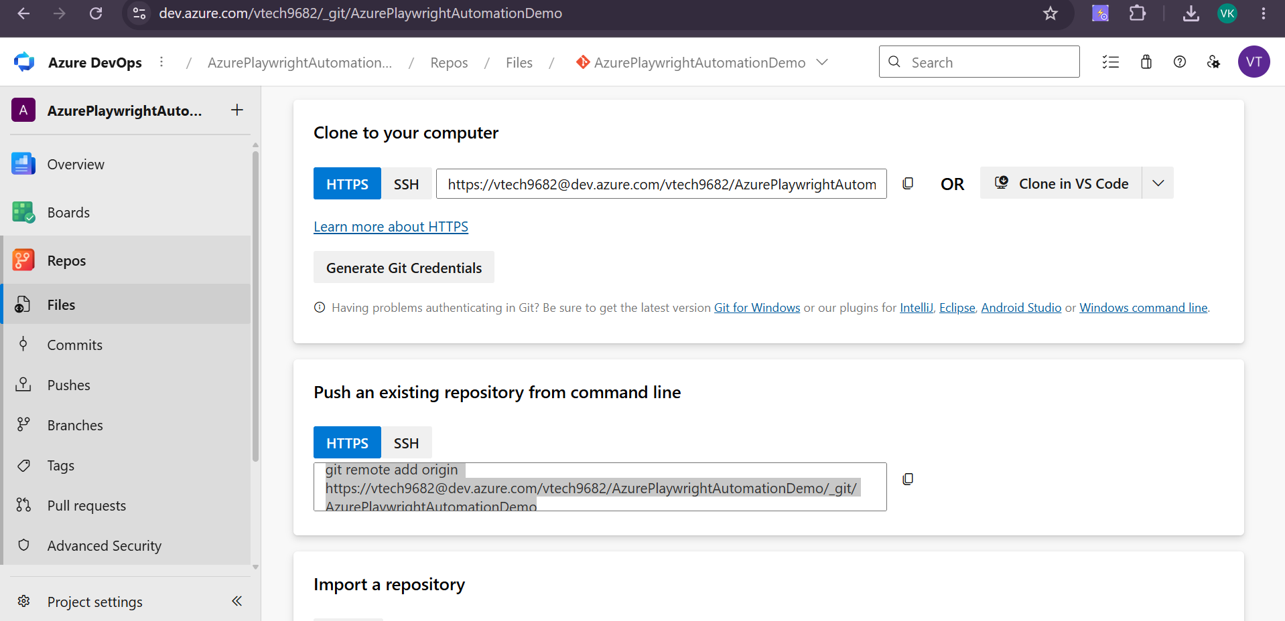

Step 3B.2 — Open Git Bash in Your Project Folder
1 | Open File Explorer and navigate to your Playwright project folder  The folder that contains package.json and playwright.config.ts

2 | Right-click inside the folder → 'Git Bash Here'  This opens Git Bash already inside your project directory

3 | Verify you are in the right folder  Run: pwd → it should show your project path

# Verify your location
pwd
# Expected output: /c/Users/YourName/PlaywrightProject (or similar)

# Verify project files exist
ls
# Expected: package.json playwright.config.ts tests/ pages/

Step 3B.3 — Check and Fix .gitignore
Before pushing, make sure you are NOT pushing unnecessary folders. Open .gitignore in VS Code and verify these lines exist:

# .gitignore — verify these entries exist
node_modules/
playwright-report/
test-results/
.env
*.log

⚠️ NOTE: If node_modules/ is missing from .gitignore, your push will upload 200MB+ of files and likely timeout or fail. Add it BEFORE running git add.

Step 3B.4 — Initialize Git and Push
Run these commands one by one in Git Bash. Do not copy-paste all at once.

Part A — Initialize Git (only if not already initialized)
# Check if git is already initialized
git status

# If you see: 'fatal: not a git repository' → run this:
git init

# If you see files listed → git is already initialized, skip git init

Part B — Stage All Files
# Stage everything (respects .gitignore automatically)
git add .

# Verify what is staged — check node_modules is NOT in the list
git status

Part C — First Commit
git commit -m "Initial commit: Playwright TypeScript framework"

Part D — Add Azure Repos as Remote
# Replace the URL below with YOUR repository URL copied from Azure DevOps
git remote add origin https://PlaywrightTraining@dev.azure.com/PlaywrightTraining/PlaywrightAutomation/_git/PlaywrightAutomation

# Verify remote is added
git remote -v
# Expected output:
# origin https://dev.azure.com/... (fetch)
# origin https://dev.azure.com/... (push)

Part E — Push Code to Azure Repos
git push -u origin main

# If your branch is 'master' instead of 'main':
git push -u origin master

🚨 IMPORTANT: When Git asks for a password — do NOT type your Microsoft account password. Paste the PAT (Personal Access Token) you copied earlier. The password field will not show what you type — that is normal.

📌 INFO: On Windows, Git may open a credential popup. In the Username field type anything (e.g. 'token'). In the Password field paste your PAT. Click OK.

Step 3B.5 — Verify Code in Azure Repos
1 | Go back to Azure DevOps in your browser

2 | Click Repos → Files

3 | You should now see all your project files listed  If you see package.json, playwright.config.ts, tests/ folder — push was successful

4 | Click on tests/ folder and verify your spec files are there  e.g. login.spec.ts, home.spec.ts

💡 TIP: Show students the file browser in Repos. They can view individual files, see commit history, and even edit files directly in the browser — just like GitHub.

PHASE 4A | Create the azure-pipelines.yml File

The pipeline is controlled by a YAML file that lives in your project. This file tells Azure DevOps exactly what to do — which Node version to use, how to install dependencies, how to run tests, and what to do with the results.

Step 4A.1 — Create the YAML File in VS Code
1 | Open your Playwright project in VS Code  File → Open Folder → select your project folder

2 | In the VS Code Explorer (left panel), click the 'New File' icon  The + icon appears when you hover over the project root in the file tree

3 | Type the filename exactly: azure-pipelines.yml  Press Enter — the file opens in the editor

🚨 IMPORTANT: This file MUST be in the ROOT folder of your project — the same level as package.json. Do NOT put it inside tests/ or pages/.

Step 4A.2 — Paste the Complete Pipeline YAML
Click inside the azure-pipelines.yml file in VS Code. Delete anything already there. Paste the following YAML exactly:

# azure-pipelines.yml
# Azure DevOps CI Pipeline for Playwright TypeScript

trigger:
branches:
include:
- main

pool:
vmImage: 'ubuntu-latest'

steps:

- task: NodeTool@0
inputs:
versionSpec: '18.x'
displayName: 'Install Node.js 18'

- script: npm ci
displayName: 'Install npm Dependencies'

- script: npx playwright install --with-deps
displayName: 'Install Playwright Browsers'

- script: npx playwright test
displayName: 'Run Playwright Tests'
continueOnError: true

- task: PublishPipelineArtifact@1
inputs:
targetPath: 'playwright-report'
artifact: 'playwright-html-report'
publishLocation: 'pipeline'
displayName: 'Publish HTML Report'
condition: always()

4 | Press Ctrl+S to save the file  You will see the file in the VS Code file tree

Step 4A.3 — Verify playwright.config.ts Has HTML Reporter
Open playwright.config.ts and confirm the reporter is configured. This generates the HTML report that the pipeline will publish.

// In playwright.config.ts — verify this section exists:
reporter: [
['html', { outputFolder: 'playwright-report', open: 'never' }]
],

⚠️ NOTE: If open is set to 'on-failure' or 'always', the pipeline will try to open a browser on the agent (which has no display) and may hang. Always set open: 'never' for CI.

Step 4A.4 — Commit and Push the YAML File
Go back to Git Bash and push the YAML file to Azure Repos:

# Stage only the new YAML file
git add azure-pipelines.yml

# Commit with a clear message
git commit -m "Add Azure DevOps CI pipeline configuration"

# Push to main branch
git push origin main

1 | Go to Azure DevOps → Repos → Files  Refresh the page

2 | Verify azure-pipelines.yml now appears in the file list  Click on it to verify the content looks correct

PHASE 4B | Create the Pipeline in Azure DevOps UI

Now we tell Azure DevOps to use our YAML file as a pipeline. This is a one-time setup. After this, every push to main will automatically trigger the pipeline.

Step 4B.1 — Navigate to Pipelines
1 | In Azure DevOps left sidebar, click 'Pipelines'  The Pipelines section expands

2 | Click 'Pipelines' in the sub-menu (not Environments, Releases, etc.)  You will see 'No pipelines have been created in this project'

3 | Click 'Create Pipeline' button  The pipeline creation wizard starts
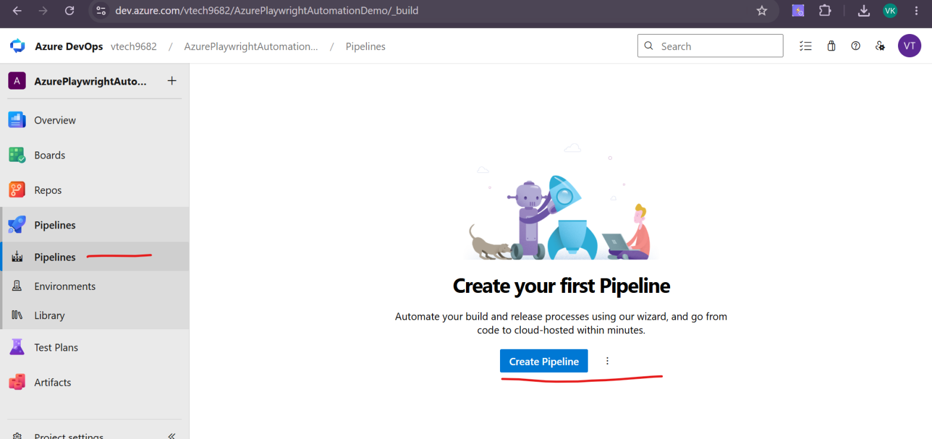

Step 4B.2 — Connect to Your Repository
The wizard has 4 tabs: Connect → Select → Configure → Review. Follow each step.
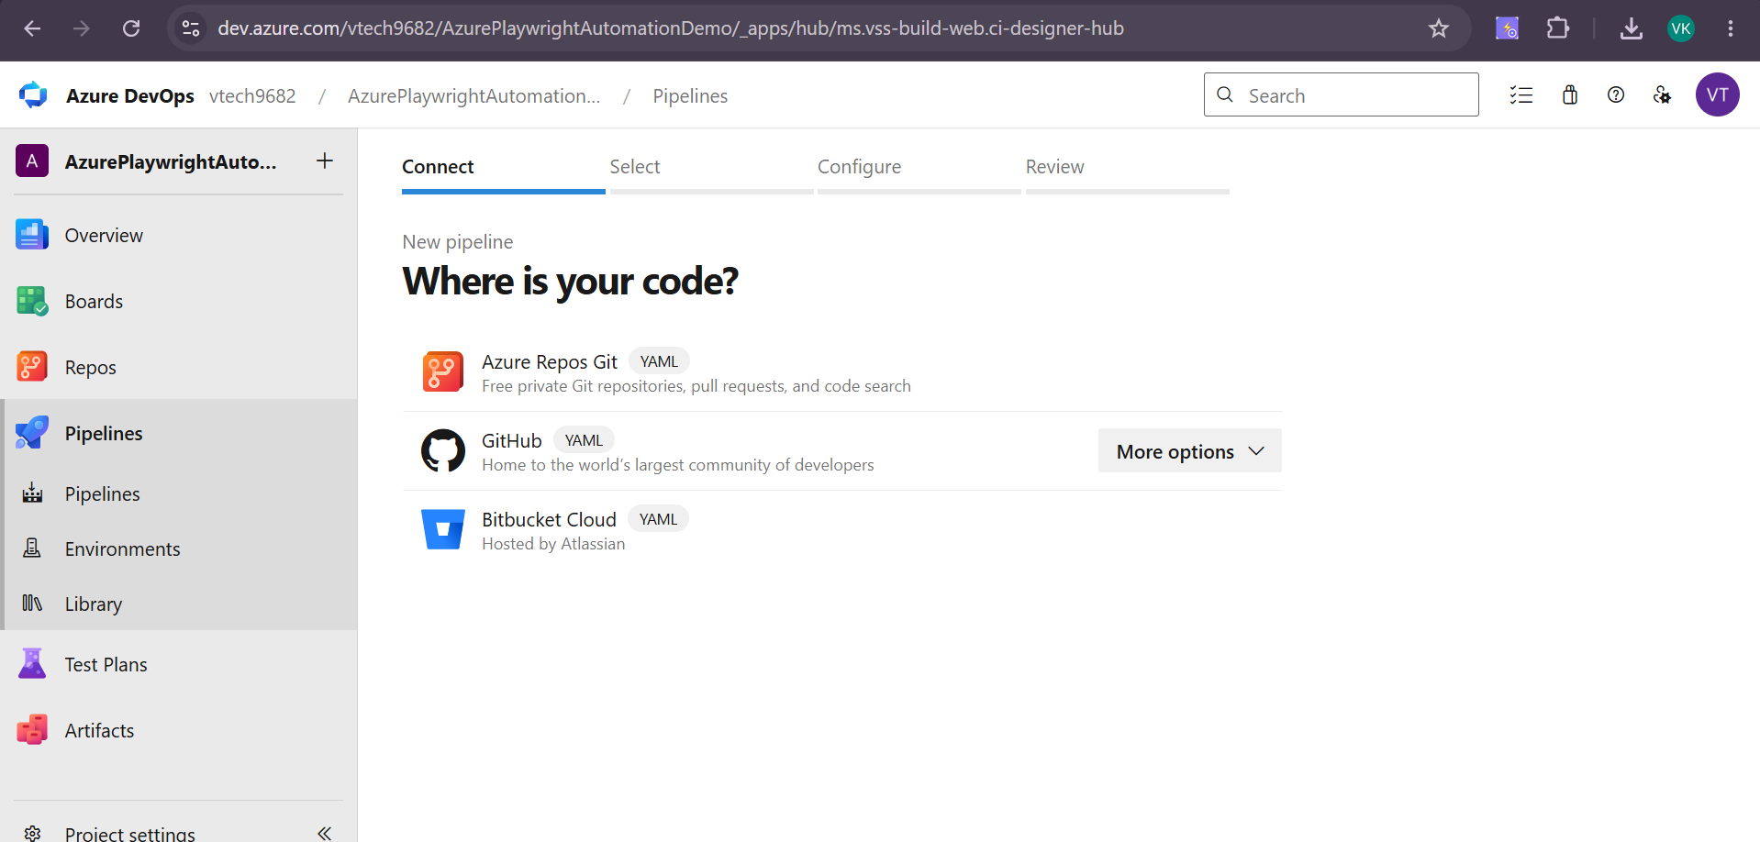

TAB 1 — Connect: Where is your code?
1 | Select 'Azure Repos Git'  Your code is in Azure Repos (we pushed it there)

💡 TIP: If your code was on GitHub, you would select GitHub here. But for this training, we use Azure Repos.
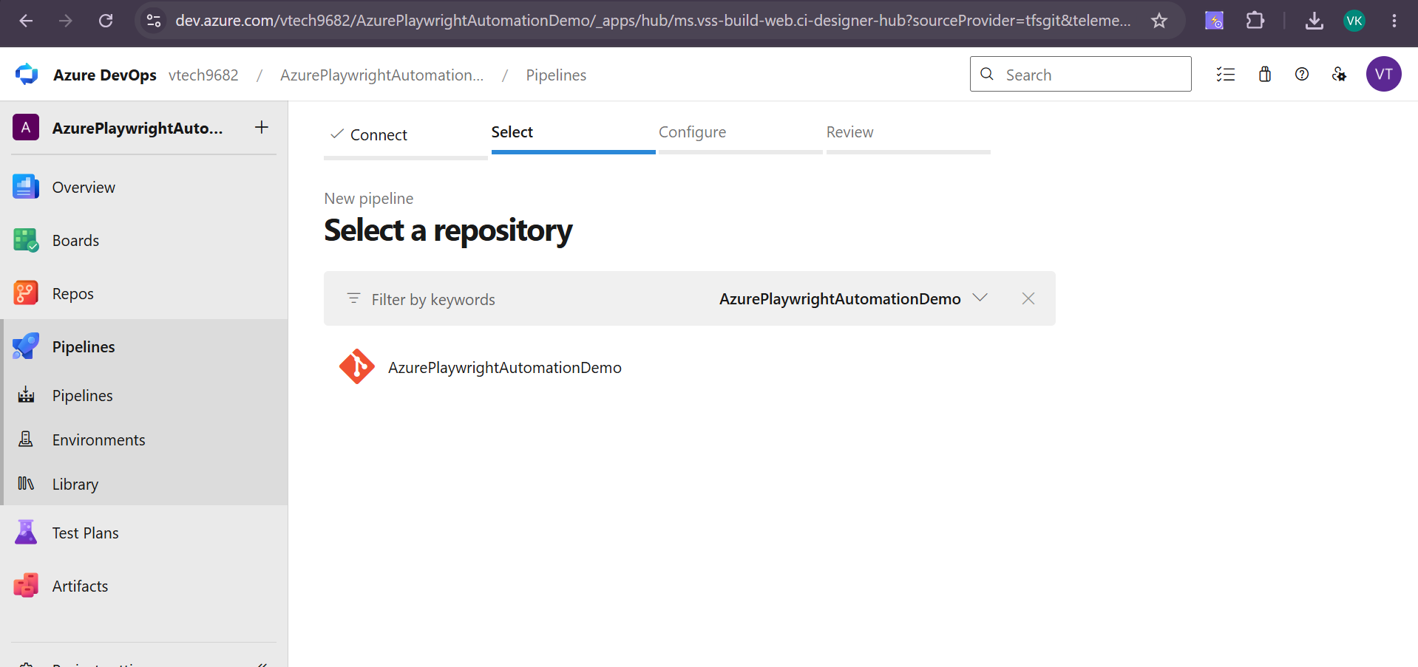

TAB 2 — Select: Which repository?
2 | You will see your repository listed: PlaywrightAutomation  Click on it to select it

TAB 3 — Configure: What kind of pipeline?
3 | Select 'Existing Azure Pipelines YAML file'  This tells Azure DevOps to use our YAML file instead of creating a new one

Branch | main  Select from dropdown

Path | /azure-pipelines.yml  Select from dropdown — it should auto-detect your file

4 | Click 'Continue'

TAB 4 — Review: Review your pipeline YAML
5 | You will see your full YAML displayed on screen  Review it — confirm it matches what you pasted in VS Code

6 | Click 'Run' (top-right blue button)  This saves the pipeline AND triggers the first run immediately

🚨 IMPORTANT: The first run may ask: 'This pipeline needs permission to access a resource'. Click 'View' → then 'Permit' → then 'Permit' again. This is a one-time authorization for the pipeline to access your repository.

PHASE 5 | Monitor the Pipeline Run & View Results
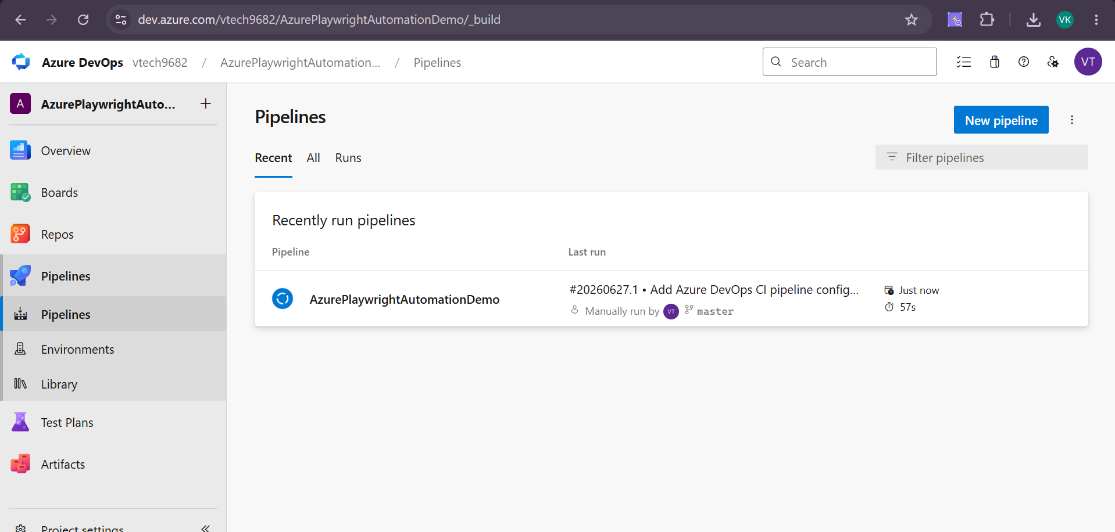

Step 5.1 — Watch the Pipeline Execute
After clicking Run, Azure DevOps takes you to the pipeline run page. You will see the pipeline status in real time.

1 | You see a circular loader — 'Queued'  Azure is assigning a free virtual machine. This takes 30-60 seconds.

2 | Status changes to 'Running' — a blue spinner appears  The Ubuntu agent has started. It will now execute your YAML steps one by one.

3 | Click on the running job name (usually 'Job')  This opens the live console log — you can see real-time output

Step 5.2 — Live Console Log — What to Look For

Log Line You Will See | What It Means
Agent version X.X.X | Microsoft's Ubuntu VM has started — pipeline is live
npm warn deprecated... | Normal npm warnings — do NOT panic. These do not cause failure.
Downloading Chromium... | Playwright is downloading browsers on the agent — takes 1-2 minutes
Running X tests using 1 worker | Your Playwright tests are now executing on the Ubuntu agent!
X passed (Xm Xs) | All tests passed! Pipeline will show green.
X failed (Xm Xs) | Some tests failed. Pipeline step shows red. But report still publishes.

Step 5.3 — Download and View the HTML Report
1 | After pipeline finishes, click the back arrow to go to the run Summary page

2 | Scroll down to the 'Artifacts' section at the bottom of the Summary  You will see: 'playwright-html-report'

3 | Click on 'playwright-html-report'  A file browser opens showing the report folder contents

4 | Click the download button (cloud icon with down arrow)  A .zip file downloads to your computer

5 | Extract the zip file  Right-click → Extract All

6 | Open the extracted folder → double-click index.html  Opens in your browser — you see the full Playwright HTML report

💡 TIP: In the HTML report, click on any test name to see: steps executed, screenshots on failure, video (if configured), and trace viewer link.
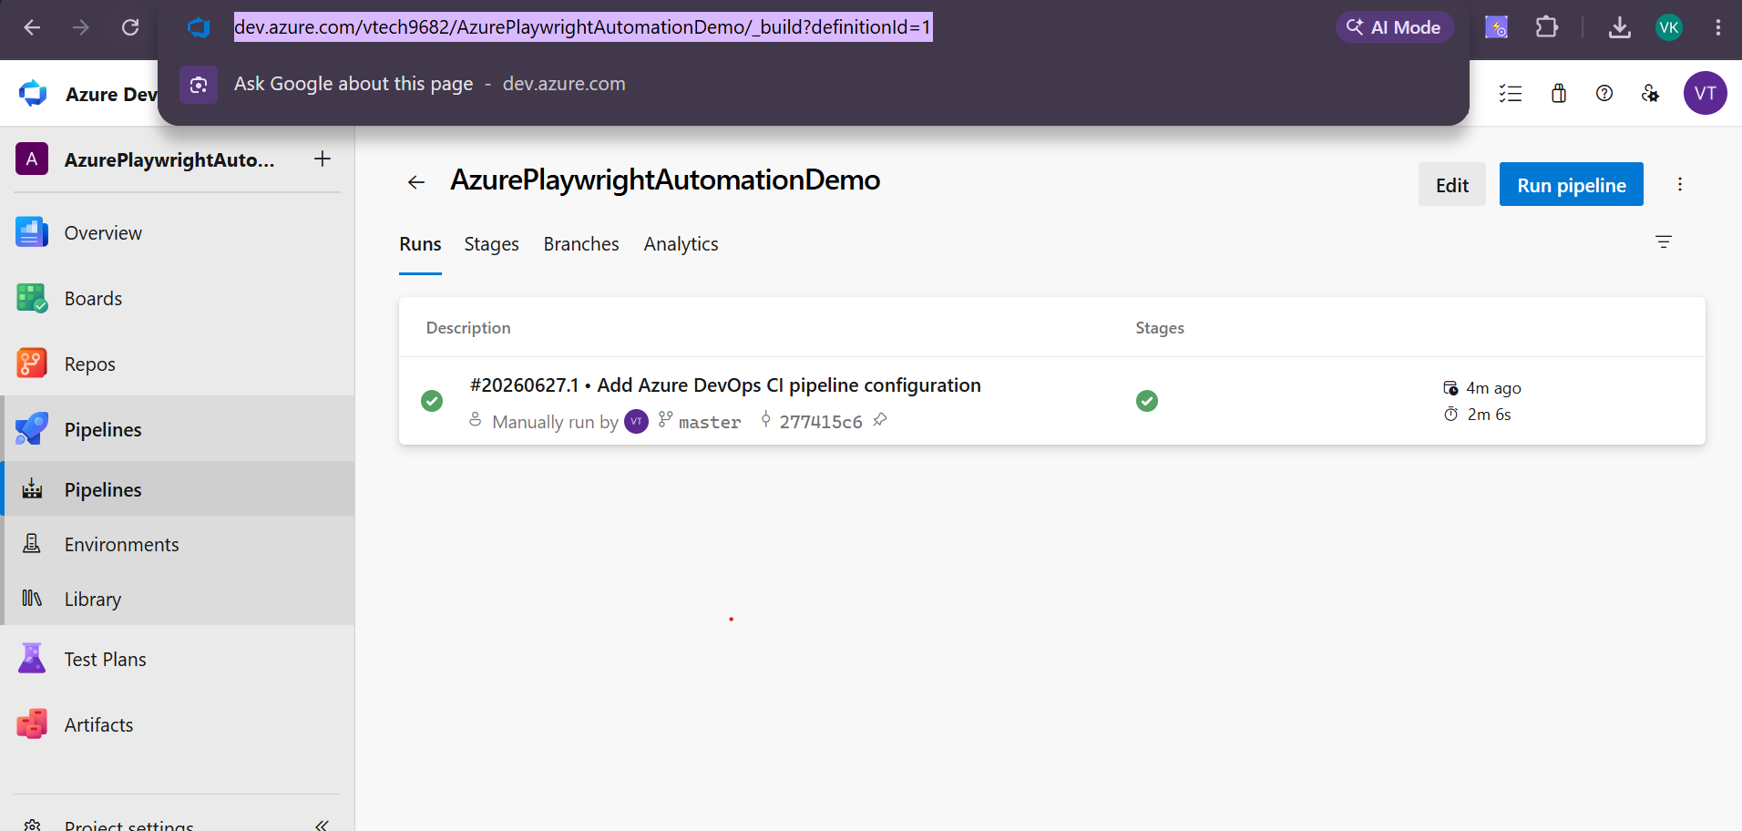

PHASE 6 | Deliberate Failure → Red Pipeline → Fix → Green Pipeline

This phase shows students the complete CI/CD feedback loop. Breaking a test and watching the pipeline respond is the most impactful part of this demo.

Step 6.1 — Break a Test Intentionally
1 | Open any spec file in VS Code  e.g. tests/login.spec.ts

2 | Find a toHaveTitle or toHaveURL assertion

// BEFORE — this is the correct, passing assertion:
await expect(page).toHaveTitle('Swag Labs');

// CHANGE IT TO — this will fail:
await expect(page).toHaveTitle('Wrong Title That Will Never Match');

3 | Save the file (Ctrl + S)

Step 6.2 — Push the Breaking Change
git add .
git commit -m "DEMO: deliberately failing assertion for CI demo"
git push origin main

Step 6.3 — Watch the Pipeline Auto-Trigger
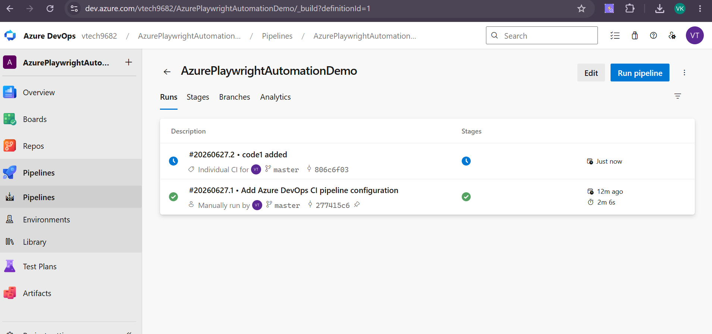
1 | Go to Azure DevOps → Pipelines

2 | You will see a new pipeline run has started AUTOMATICALLY  This proves the trigger: section in the YAML is working

3 | Click on the running job to open the live log  Watch the test execution step — it will show the failure

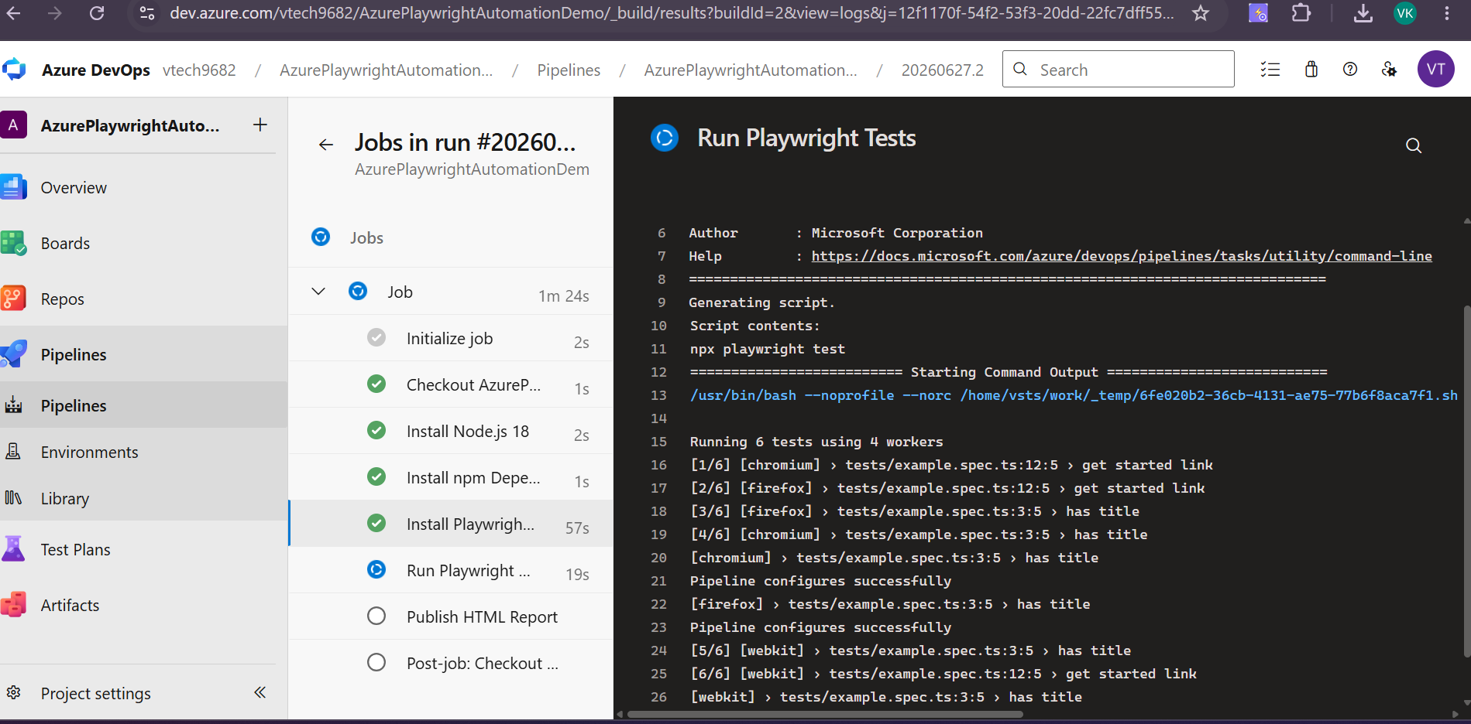

4 | After tests finish, the step shows a red X — but the pipeline continues  Because we set continueOnError: true

5 | The 'Publish HTML Report' step runs and completes green  Because we set condition: always()

6 | Overall pipeline status: FAILED (shown in red at the top)  This is the expected behavior

Step 6.4 — View the Failure in the HTML Report
1 | Download the HTML report artifact (same steps as Phase 5.3)

2 | Open index.html — you will see the failing test highlighted in red

3 | Click on the failing test name  You see: Error message, Expected vs Received values, Screenshot at point of failure

📌 INFO: Playwright auto-captures a screenshot and page title at the point of failure. This is why Playwright is so popular — failures are self-documenting.

Step 6.5 — Fix the Test and Get Green Build
1 | Go back to VS Code → revert the assertion to correct value

// Restore the correct assertion:
await expect(page).toHaveTitle('Swag Labs');

git add .
git commit -m "Fix: restore correct title assertion after demo"
git push origin main

2 | Watch Azure DevOps — new pipeline run auto-triggers

3 | All steps complete with green checkmarks

4 | Overall status: SUCCEEDED (shown in green)  Celebrate this moment with students — they have a working CI/CD pipeline!

Quick Reference — All Commands in Order

# ─── PHASE 3B: Push code to Azure Repos ─────────────────────

git init # Only if not already a git repo
git add .
git commit -m "Initial commit: Playwright framework"
git remote add origin https://YOUR_ORG@dev.azure.com/YOUR_ORG/PlaywrightAutomation/_git/PlaywrightAutomation
git remote -v # Verify remote is set correctly
git push -u origin main
OR
git push -u origin master

# When password is asked → paste your PAT token

# ─── PHASE 4A: Add pipeline YAML and push ───────────────────

# Create azure-pipelines.yml in VS Code (paste the YAML content)
git add azure-pipelines.yml
git commit -m "Add Azure DevOps pipeline configuration"
git push origin main

# ─── PHASE 6: Failure demo ───────────────────────────────────

# Break a test in VS Code → save
git add .
git commit -m "DEMO: deliberate failure"
git push origin main
# Watch pipeline fail on Azure DevOps

# Fix the test in VS Code → save
git add .
git commit -m "Fix: restore correct assertion"
git push origin main
# Watch pipeline go green

Troubleshooting — Common Errors & Fixes

Error / Problem | Solution
Git push asks for username/password | Username: type anything (e.g. 'token'). Password: paste your PAT. Not your Microsoft password.
remote origin already exists | Run: git remote remove origin → then add it again
error: src refspec main does not match any | Your branch might be called 'master'. Run: git push -u origin master
Pipeline shows 0 tests found | Check playwright.config.ts — testDir should be './tests' and files should match '**/*.spec.ts'
Browsers install fails on agent | Add this step before browser install: script: sudo apt-get update -qq
Report artifact not published | Ensure condition: always() is on the PublishPipelineArtifact step. Check outputFolder in playwright.config.ts matches targetPath in YAML.
Pipeline not triggering on push | Verify azure-pipelines.yml is in ROOT folder. Verify trigger branch name matches your branch (main vs master).
Permission denied on pipeline creation | Click 'View' on the permission request popup → click 'Permit' twice
PAT expired / authentication failed | Create a new PAT in Azure DevOps. Update credentials: git credential reject https://dev.azure.com then push again.
node_modules folder uploaded to repo | Add node_modules/ to .gitignore. Remove: git rm -r --cached node_modules → commit → push

End of Practical Implementation Guide — Playwright Azure DevOps CI/CD

